# **Course – 3 (Week-5)** Linux and Encryption: Final Project Overview

**Task 1: Set up user and group accounts in Kali Linux**

1. Create the user account **cdiaz** in Kali Linux.

1. Create a user group **analysts** and add **cdiaz** to this user group in Kali Linux.

## ****Task 2: Encrypt a file****

1. Create a new text file in Kali Linux named **confidential**.

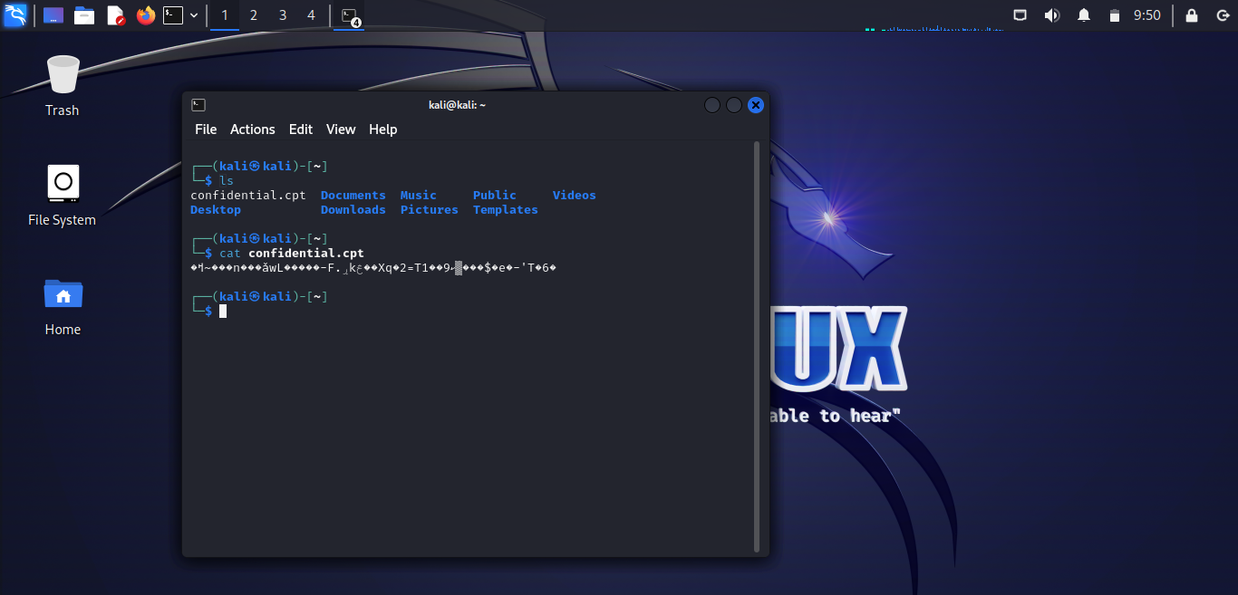

1. Encrypt **confidential** using **ccrypt**.

## ****Task 3****

1. Provide a screenshot of an encrypted email created in Mailvelope. The body of the email must include Cynthia’s username and password and the encryption key for the encrypted file. (2 pts)

